**ASTR 257 Project 4:**

**Adaptive Optics Imaging of Neptune**

**Overview**

Adaptive optics (AO) is used to make sharp images of astronomical objects through the turbulence of Earth’s atmosphere. Thanks in large part to the efforts of UCSC professor Claire Max and her Lick Observatory laser guide star, adaptive optics is now used in almost every sub-field of astronomy.

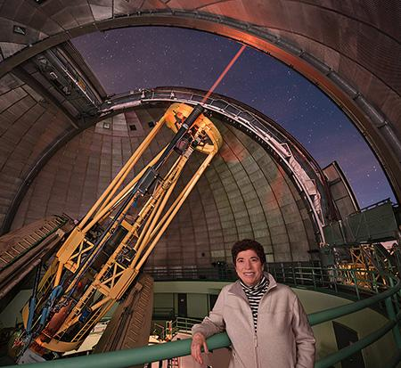

*Figure 1: UCO Director and UCSC Professor Claire Max standing next to the Shane telescope with its laser-guide star adaptive optics system.*

Tonight, we’ll be imaging Neptune with natural guide star (no laser) adaptive optics. Observations like these are frequently used to monitor Neptune’s storms and global cloud patterns. Additionally, AO images of planets look really awesome, which brings us to the goal of tonight’s project: we will image Neptune at multiple infrared wavelengths and combine the images into a color “press-release” image. In addition to data reduction, you will need to use your artistic skills and personal aesthetics for this project.

**Learning Objectives:**

* Students will learn to plan and execute AO imaging observations with Shane-AO and the ShARCS infrared camera.
* Students will learn the basics of infrared astronomical data reduction.
* Students will learn to make false color astronomical images.
* Students will learn to present their observations in a standard written format that is appropriate for publication.

**Planning Your Observations**

By now you know the basic steps of preparing for an observing night. Where is the object in the sky? Do I need a finder chart? How long should I integrate and at what wavelengths? What calibrations do I need? How do I use the telescope/instrument software? Please do whatever basic preparations you think will be useful. Keep in mind several observational techniques that are new to this project:

***Choosing an AO Guide Star***

Normally, a major part of preparing AO observations is to make sure your source is bright enough (if you’re guiding on source), or that there’s a bright enough guide star nearby (if you’re guiding off source), or that you can use a laser with a nearby tip-tilt star (usually involves prior preparation so that the observations can be cleared by “Space Command”). Tonight, we will be guiding on Neptune itself, which is plenty bright enough for adaptive optics, although the fact that it isn’t a point source can cause problems for AO systems. In this case, Shane-AO has locked on Neptune before, so we know this will work. At Shane and at many other telescopes, it is the observer’s responsibility to know what guide star they want, but a support astronomer is responsible for actually running the adaptive optics system.

***Choosing a dither pattern***

In the infrared, the sky background is often much brighter than the sources we observe. The standard way to deal with this is to dither the telescope. A two-point dither (sometimes called a “nod”) involves taking an image, moving the telescope and taking another image. If you subtract the two images, the sky background will go away and you will be left with two images of your source, separated by the nod distance. One source will be positive and one source will be negative, but it’s straightforward to add them together in post-processing (see Figure 2). Often times, astronomers use 4- (or more) point dither patterns. In this case you will have 4 images, each with your source on a different part of the detector. To remove the sky-background, you can median combine the four images and then subtract that median from each individual image. Both of these techniques also have the benefit of mitigating the effects of bad pixels, which are more common with infrared detectors than optical CCDs.

Think about whether two dithers or four dithers gives you better S/N and read the ShARCS webpage to see whether they have a standard approach:

<http://mthamilton.ucolick.org/techdocs/instruments/sharcs/intro/>

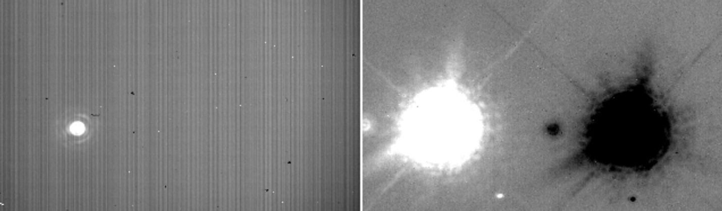

*Figure 2: Left—Raw Infrared image with a high sky background and detector noise. Right—Nod subtracted infrared image. The sky background and detector noise have both been removed.*

**Making a 3-Color Image (Ideally During the Field Trip)**

***Data Reduction***

You will need to reduce your data and combine multiple images of Neptune in order to achieve a high S/N for making a nice-looking image. If you need to align different dithers to each other, or different wavelength images to each other, here is a description of Python code for image registration:

<https://image-registration.readthedocs.io/en/latest/>

***Making a 3-Color Image in ds9***

Once you have 3 reduced images at 3 different wavelengths that are co-aligned, ds9 can make 3-Color images in a gui environment:

<http://ds9.si.edu/doc/user/rgb/index.html>

You can stretch each wavelength individually to make something that is aesthetically pleasing.

**Writeup (To Be Completed After the Field Trip)**

Please write descriptions of your Observations and Reductions. Your Reductions section can be part of the Observations section, or it can be its own separate section. I expect your Observations section to be publication quality, and your Reductions section to be clear, but not necessarily at the level of detail seen in publications. And of course, include your 3-color image.